Over the course of 2 weeks, I contributed to the website application for a local theatre in Portland, Theatre Vertigo.

This application was created using C# with ASP.net MVC .Net Framework in Visual Studio.

I created the entire About page, displaying various information about the Theatre and its history. I created this entirely from scratch using HTML. I used CSS and Bootstrap to make the page mobile responsive, so that it displays well on a mobile device as well as a desktop.

Additionally, I rendered the Sponsor Links that appear at the bottom of the HTML from another MVC, the Sponsors MVC.

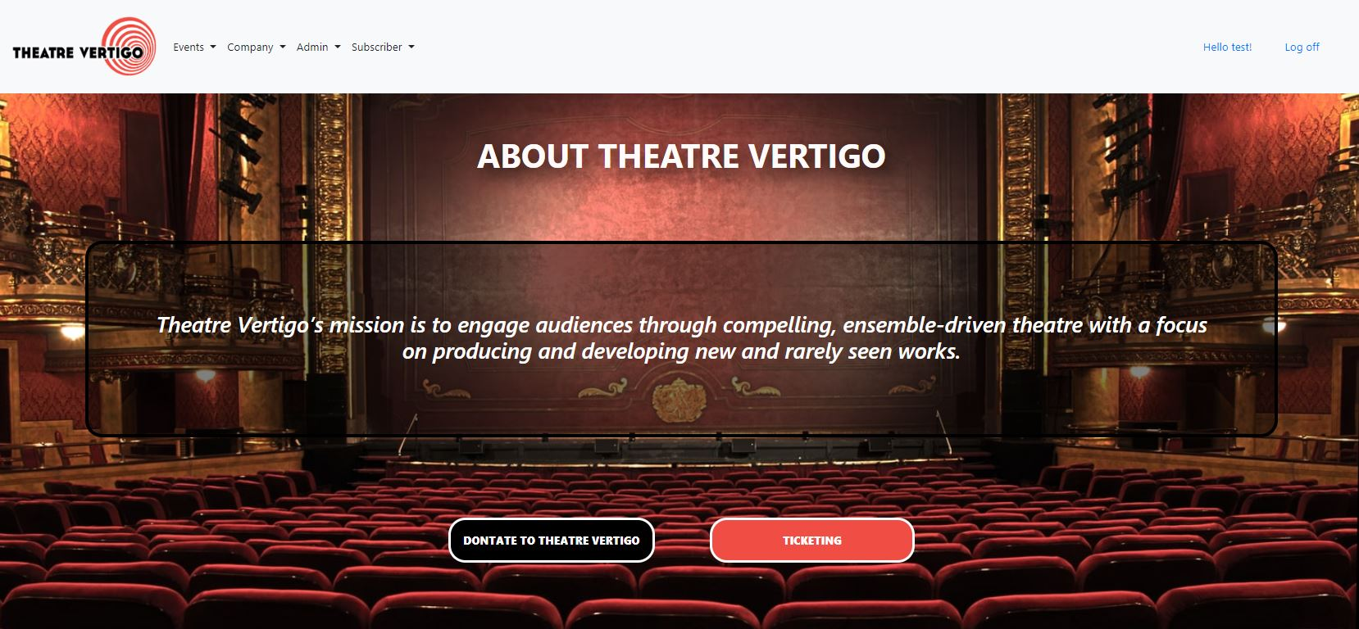

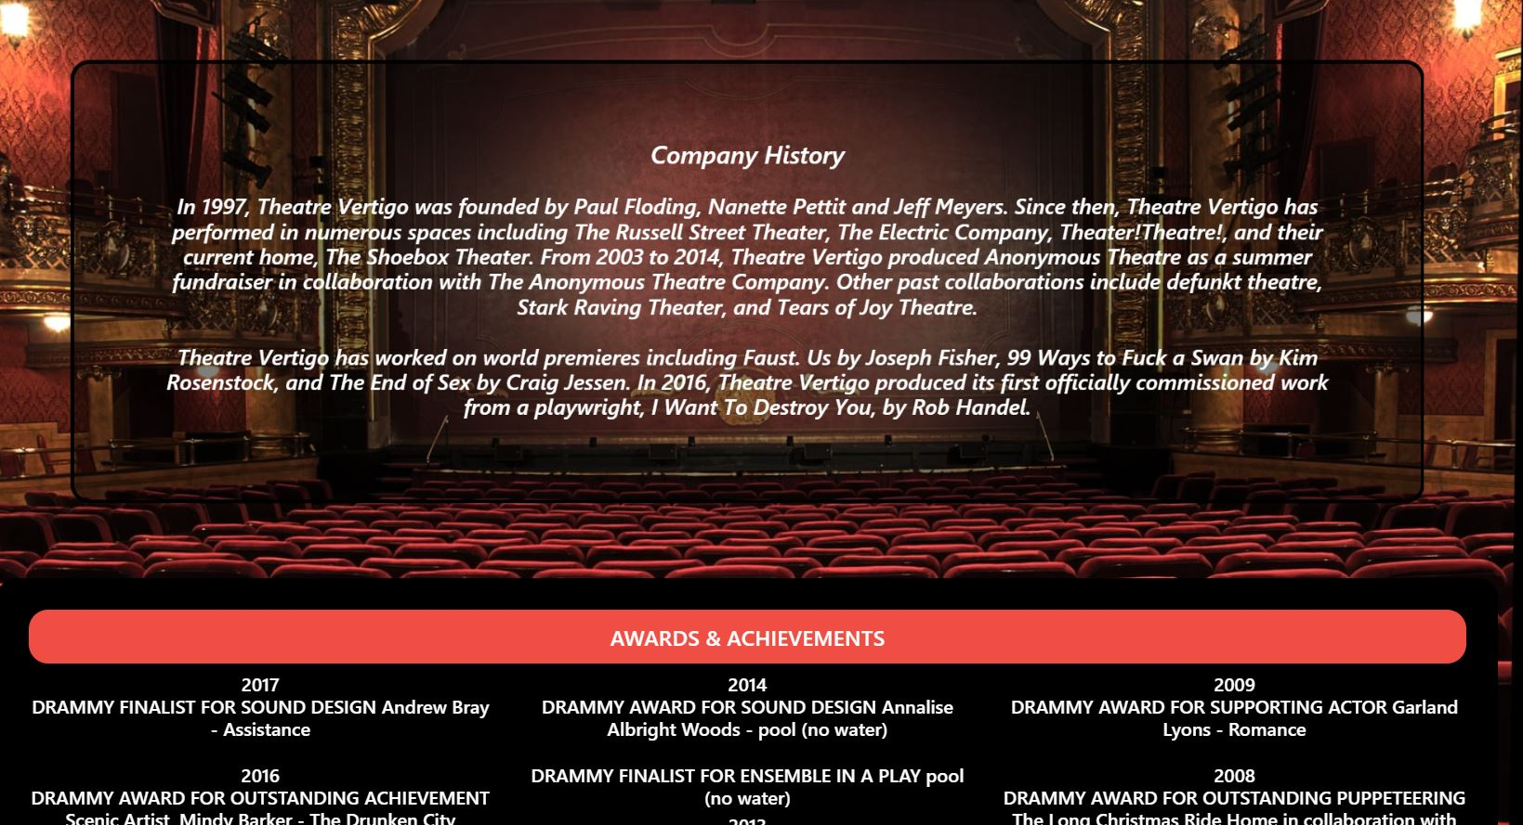

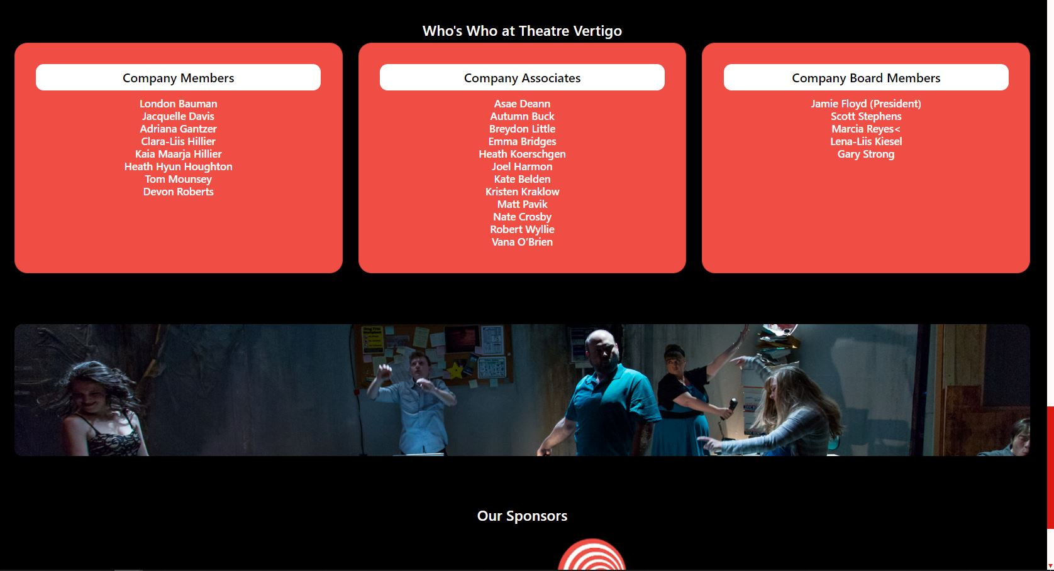

Below is my code.